**From:** Fachko, John   
**Sent:** Friday, April 08, 2016 2:36 PM  
**To:** Moldow, Austin  
**Subject:** RE: files

I guess it depends on where the script resides.

What I did was I went to the folder that the script was in and then held the [shift] key and right-clicked on a blank spot in the window and choose, “Open command window here”

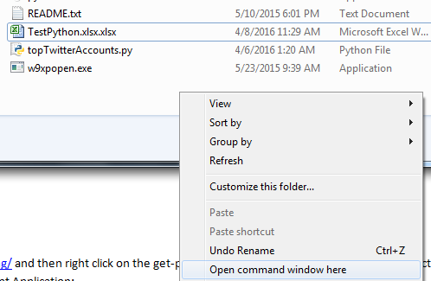

* I then typed in **python.exe toptwitteraccounts.py**
* It then started to run. When it was finished the Excel file was put in this directory.

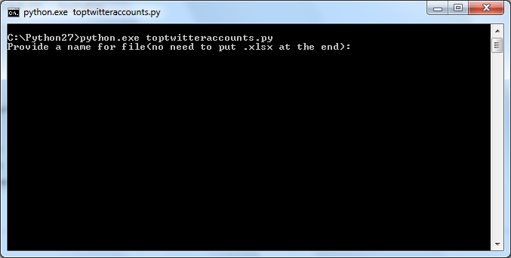

I am sure there are many ways to do this, but I haven’t worked with it enough yet.

**From:** Moldow, Austin   
**Sent:** Friday, April 08, 2016 2:24 PM  
**To:** Fachko, John  
**Subject:** files

Where do the finished twitter excel files get saved?